Jake Halverson
English 2010
Final Portfolio: Cover Letter
By completing the documents for my final portfolio, I have learned many useful skills that I can utilize throughout my education and in many work situations. The first skill is being able to argue intellectually and appropriately with the use of research and examples, as demonstrated by my position paper. This skill was used in my other projects in the class as well. The brochure, for example, used much of the same research I found when writing my position paper, and the review had specific examples from the film to support my thesis.
Another skill I have learned is how to adjust my tone and citations to fit specific circumstances. By knowing and utilizing this skill, I was able to effectively write and communicate my theses through other genres. This is important since no two genres use the same type of structure or language. For example, the review and brochure’s citations and language were much more informal than what is expected in a position paper.
Perhaps the most applicable skill I have learned is how to create and revise drafts. Peer reviews and comments throughout the course gave me direction and new ideas to illustrate my points and make my documents more precise and effective. For example, the recommendation to include more research and specifics really pushed me to be more precise and turn my less direct and sometimes vague first drafts into more substantial, effective documents.
By reading and reviewing the documents of my peers, I was able to utilize the strong techniques in their writing to strengthen my own. I feel like most of my comments were also useful to the writers in some way, such as my comments on thesis statements earlier in the semester about the relevance of other points within the documents to the theses. As I continued to become more research oriented in my writing, however, my comments began to suggest more examples related to specific points. Both types of analyses can be very useful in revisions.
The main revisions I made in my documents before submitting them to my final portfolio ranged from adding more information and examples, to playing devil’s advocate, and even using less information to help the design of a document. Examples of these can be seen in the added examples and precision of wording in my position paper, considering the counterpoints more fully in my review, and focusing on the visual esthetics of the brochure rather than the heavy use of information. These kinds of revisions really helped me to grasp the use of each of the genres, and ultimately make more effective use of them.
I feel that compiling these documents and revising each of them has helped me become a better writer because it has made me to think about my body of work as a whole. I’ve decided that the brochure really speaks for my design capabilities when writing a document, the position paper shows that I am capable of research and tying what I learn to a main point, and the review shows that I am able to analyze somebody else’s work and find strengths and weaknesses. Although my review is the strongest piece in my final portfolio, all three of the documents I have chosen add an important component to the project.
In the end, I feel that this class has definitely taught me useful skills, such as revision and concept of genre. It has also taught me the importance of working as a group and taking the opinions of others into account when doing my own writing. I will be able to carry these skills and concepts into other areas of study and work as I progress.
[Review]
Jake Halverson
English 2010
A Convenient Political Opportunity
In “An Inconvenient Truth” Al Gore gives a presentation about global warming to various groups of people. On the surface this may just seem like a good act by a strong environmentalist. As I watched the film however, another agenda came forward more than just incidentally. His political drive is apparent throughout the film and I am left with the question of what his real intention really was. It’s difficult to say whether these efforts to gain favor are to build momentum for a future presidential campaign or if he has another government position in mind. One thing is certain though, Al Gore has made it a point to demonstrate his political prowess throughout this supposedly informative presentation.
Gore’s presentation shares many valid arguments as to the importance of reducing carbon emissions. Scientific facts and statistics regarding greenhouse gasses and the process of global warming are commonly shared with his audience throughout. These are all presented in an understandable manner with pictures and charts to illustrate his points. Along with these less arguable subjects however, there are several insults to the Bush administration. He also is not afraid to discuss his own political debates and triumphs related to environmental awareness. Perhaps his intentions were to inform, and much of the information presented would serve that end, but I question the relevance of much of the material shared in this film.
One example of good information shared was the basic layout of global warming. With an animated model, Gore explains the process of infrared heat trapped by greenhouse gasses, causing the warming of the earth’s atmosphere. He then shows an animated video clip, demonstrating the same point, but using humor as a tool for both entertainment value and helping his audience grasp the point. This shows the mark of a genuine environmentalist with a drive to help the audience understand.
Early in the film, he shares a story about a grade school teacher who taught his students that the continents on earth never fit together, which we now know is a false teaching. He then says the student went on to be a drug addict and the teacher became the science advisor in the Bush administration. Insinuating that President Bush’s policy relies on false teachings is in no way related to promoting the green movement. In fact, petty insults to opposing political parties are a commonly used to gain favor in elections.
He then continues into another scientific argument for global warming, centralizing on a chart (shown below) regarding the CO2 levels in the atmosphere over several years. This is another strong point for environmental awareness. The raised CO2 levels and raised global temperatures have caused the melting of many glaciers around the world. These glaciers are a huge source of drinking water for humans.
Atmospheric CO2 at Mauna Loa Observatory (Dr. Peter Tans)
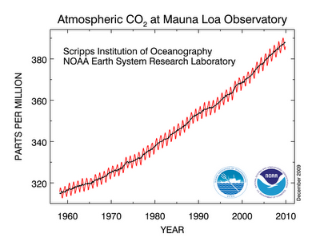
Instead of simply presenting his point however, Gore discusses his endeavors to resolve these issues, including writing a book and presenting to the senate and science round tables. He talks about Bush’s failure to regulate Carbon Dioxide as well, a pledge that he made in his presidential campaign. Also, about half way through the video there was also a small video and sound clip montage concerning the election between George W. Bush and Al Gore. By sharing this off topic information, it makes me view this part of the presentation as some sort of guilt trip for American voters. If the purpose of the global warming video was to raise awareness and concern, why would presidential elections have anything to do with it?
As the film goes on, the main topic becomes less of a scientific informative presentation and more of a calling for moral consideration and thought change. Gore makes comparisons with tobacco and how the health view has changed over the years. This was a great comparison. Being able to relate current events to similar situations in the past can be very helpful in trying to convince people to reach a similar verdict.
It seems, however, that this information was only to create another opportunity to talk about the Bush administration. Gore talks about scientific reports and how some members of the White House were editing them to reduce any controversial findings regarding global warming. Sharing this information could have a couple different purposes. One very relative topic to going green concerns the relationship between government administration and academic findings. Most citizens would agree that regardless of repercussions related to government policy, findings that can benefit society should be shared regardless. Although this shift to politics may have been appropriate, the various other examples of politicking in Gore’s presentation leads me to assume that this was yet another bash on Bush to gain favor from his viewers.
This trend continues soon after when he is talking about the economic effects of being environmentally efficient. He addresses a misconception regarding the change from our current lifestyle to a greener lifestyle, namely that we don’t have the knowhow to change to a greener lifestyle. He disproves this misconception, and then says that we have everything except for political will, but in America, “Political will is a renewable resource” (Gore). Although he is no longer running for office, this kind of “call to action” for American voters is a common type of headlining phrase in campaigns.
Al Gore’s wit and charisma may have been appropriate when used in his presidential campaign; however, when he continues that into what is trying to be put off as a purely informative and awareness raising presentation, it makes the purpose of that presentation much less clear and brings into question its intention.
Overall this film was very informative. There were many facts and concepts that could be useful in gaining an understanding of global warming and its causes and effects. It is clear however, as seen by the information shared above, that Al Gore’s purpose for producing this video was to have some sort of political gain.
This type of manipulation of scientific ideas into a platform for political eminence reflects poorly upon the whole eco-friendly movement. It begins to be seen as less of a real issue and more of some sort of utility for popularity.

Works Cited
An Inconvenient Truth [video Recording]: a Global Warning. Perf. Al Gore. Paramount, 2006. Online Video
Dr. Pieter Tans, NOAA/ESRL (www.esrl.noaa.gov/gmd/ccgg/trends/) and Dr. Ralph Keeling, Scripps Institution of Oceanography (scrippsco2.ucsd.edu/).

Position
Jake Halverson
English 2010
Green is Good
It is clear that the green movement in the United States is going to continue to grow and become a major factor in our economy. As this becomes more prominent there are a few things we as citizens should be aware of. Most important of these is that the job market is going to be changing. Whether it is simple changes like the light bulbs being switched out in offices, or a completely new industry opening up, we can expect to see new work environments and new types of work as employers weigh the pros and cons of going green for their companies. While some would argue that the initial cost of going green outweighs the long term benefits, I will show how by adopting environmentally friendly practices, companies can grow more in the long run. Going green will create a better, more profitable working field for the United States.
Cost Effectiveness
Some would argue that green technology is not cost effective. Patrick Michaels, a Fellow in Environmental Studies at the Cato Institute, says in his interview with Fox Business News that the environmentally friendly technologies cost more than conventional energy sources. He also says that without the government subsidies, the environmental industry would not be able to “stand on its own two feet” (Michaels).
While he is correct in saying that government involvement has been one of the major stimuli for the green movement, he fails to recognize the positive economic effect companies are seeing prior to implementing greener practices. We can see evidence of this in companies such as GE (General Electric). In 2009 they had more than 10,000 wind turbine installations, one of which, for Caithness Energy (a power company in Oregon) would produce $16 million in economic benefits for their state annually. The construction of the site would employ 400 workers and, and during operation would employ 35 (Associated Press par 3-6). This example not only shows the creation of new jobs, but also a huge income and economic benefit for both companies, as well as for the state of Oregon.
Caithness Energy’s Windmills (Ecomagination)
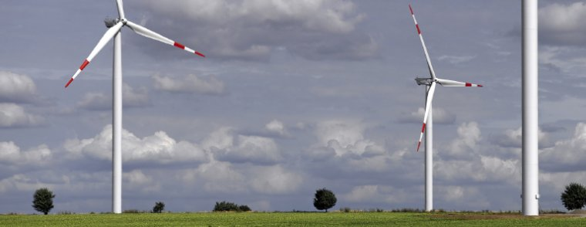
Companies
These kinds of situations are seen in many companies across the board. In the article “Companies Discover Going Green Pays Off” in USA Today, Edward Iwata explains how Sun Microsystems, a technology company, is saving hundreds of millions of dollars by using energy saving technology in its computer chips and allowing employees to work from home. Here we can see environmental and cost benefits as well as a better more friendly type of work for the employees. From this information, we can see that there is more than one way that going green can benefit a company.
Larger companies are not the only businesses who are experiencing growth due to the green movement. By starting businesses green, small business owners are able to save on energy costs, costs of waste disposal, as well as costs for employees who become sick due to the less clean work environments of conventional work places. Because of the long term benefits, government aids associated with green practices, and the positive publicity of the media, many owners are taking advantage of and reaping the benefits of the new kind of business.
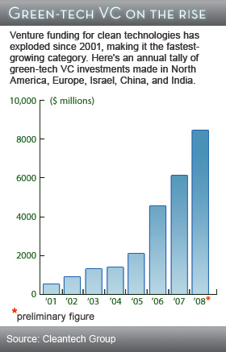
Whole Foods Market is a prime example of a company who has seen huge amounts of success while going green. They began as a small one store business in Texas, but have become a leading retailer of natural foods. Much of this could be attributed to the company’s commitment to green business standards (Sba.gov par 3). Whole Foods Market is continuing its green movement by investing in solar and wind power, green building techniques that reduce the toxic gas-off created by conventional buildings, biodiesel for their truck shipments and even green cleaning supplies (Whole Foods Market). By going green, this company has seen huge benefits for the growth of their company that may have not been possible without the green practices.
As seen in the graph to the left, funding has also increased for cleaner technologies
globally. This means that more options will become available for employers and employees. The more options and work opportunities the citizens of the United States have, the more stable the economy will become.
Career Oportunities
Health Insurance: Medical, Dental, Vision & Dependent Coverage | Trade Benefits
Paid Time Off (PTO): Vacation, Sick Leave, Holidays | Mileage Allowances
Paid Over-Time | Service Awards
Flexible Work Scheduling | Employee Purchases (i.e., replacement of worn-out tools)
401-K Plans and IRAs | Employee Assistance Programs
Profit-sharing | Additional Unpaid Time off
Bonuses | Union Membership Related Benefits such as protection and
New types of careers as well as current career options are becoming more applicable to the job market due to the change associated with figure 2 (Pinderhughes) going green. Such positions include mechanical engineers (for solar and wind industries), environmental engineers, environmental educators, heating and cooling installers, and arborists (The Green Finance par 3-7). This increase in job applicability will motivate both current employees and those beginning to work to gain skills that can be used in the new job market. Raquel Pinderhughes Ph.D. demonstrates this in her case study of Berkeley California titled “Green Collar Jobs”. In it, she explains how green jobs are offering employees “meaningful, community serving work, living wages, benefits, and advancement opportunities” (Pinderhughes par 3). This study also shows the benefits and availability of these green jobs to workers with work barriers such as a previous incarceration, no high school diploma/limited education, old age, or few skills needed for other work. Common wages and benefits are illustrated in the image above. These new options will help lift poverty stricken families from their situations and aid in decreasing the unemployment rate in the United States.
Overall, the green movement is going to strengthen industries that embrace the new way of working. It will also create a way for new businesses to become profitable by implementing green technologies their current situations and ways of working. Along with these improvements, the unemployment rate will be positively affected.
Too Much Government Control?

A final argument from those who oppose the green movement in work places is that the government has too much of a hand in it. This Financial Stimulus (Howe) argument is represented by John Stossel’s video, titled “The Green Jobs Fallacy”. He says that the government cannot create new types of jobs or careers; it simply moves funds or taxes to where they feel it would create a bigger benefit for the nation. This, according to John Stossel, is known as “The Broken Window Fallacy”. He uses the metaphor of breaking a window to create jobs for a janitor and a glass repair man. While those specific jobs are being created, which others are being neglected? In the economy, the more profitable companies will naturally become so, because consumers see a benefit. The government “breaking a window” so to speak is just a way of trying to control the economy. If not for the tax incentives, would the cost of going green really be worth it for the business (Stossel)? Is the instant growth going to be continued by these green companies?
The answer is yes. The incentives are put in place to start a green movement on a larger scale which would include new and small businesses that are less able to pay the initial cost to go green. One such yoga company in California, The Bo Tree, recently renovated one of their studios to be completely environmentally friendly. This included cork floors, environmentally friendly paints, bamboo and recycled wheat board cabinets and halogen and fluorescent lighting. They also clean with nonchemical substances like vinegar or baking soda, and print their flyers or brochures on recycled materials. Because of these choices and practices, the Bo Tree saves an estimated $1000 a year in costs (California Air Resources Board). Larger companies such as GE discussed above also see huge long term economical benefits from going green. Ultimately, companies who go green will see benefits reaching far past the initial growth stimulated by government subsidies.
Discussion
From the information above, we can conclude that going green is going to have a long term positive effect on the job market, and thereby have a positive effect on the economy as a whole. New, old, small, and large companies are beginning to see the positive effect that going green is having on their bottom line. This trend is leading to a new way of work, and a new way of life for American citizens.

Works Cited
Associated Press. "GE Inks Largest Wind Turbine Contract Ever - Business - Going Green - Msnbc.com." Msnbc.com - Breaking News, Science and Tech News, World News, US News, Local News- Msnbc.com. 10 Dec. 2009. Web. 10 Oct. 2011. <http://www.msnbc.msn.com/id/34360460/ns/business-going_green/>.
California Air Resources Board. "Eco-Friendly Exercise | Cool California." Cool California | Cool California. Web. 18 Oct. 2011. <http://coolcalifornia.org/case-study/eco-friendly-exercise>.
Ecomagination. Caithness Energy's Windmills. Digital image. 2011. Web. 19 Oct. 2011. <http://www.ecomagination.com/progress/innovation/renewables/caithness/>.
Going Green: Not Cost Effective. Prod. Fox Business News. Perf. Patrick Michaels. Going Green: Not Cost Effective. Fox Business News, 04 May 2011. Web. 18 Oct. 2011. <http://video.foxbusiness.com/v/3969640/going-green-not-cost-effective/?playlist_id=87071>.
Howe, Bob. "Financial Stimulus." Comic strip. Institutional Advisors, 2009. Print
Iwata, Edward. "Companies Discover Going Green Pays off - USATODAY.com." News, Travel, Weather, Entertainment, Sports, Technology, U.S. & World - USATODAY.com. USA Today, 22 May 2008. Web. 18 Oct. 2011. <http://www.usatoday.com/money/industries/environment/2008-05-20-green-companies_N.htm>.
The Green Finance. "Green Business Growth | Houston Green Scene." Houston Green Scene | Connecting, Informing and Inspiring Houstonians for a Greener City. Web. 10 Oct. 2011. <http://houstongreenscene.org/houston-green-news/green-business-growth>.
Pinderhughes, Raquel. "Green Collar Jobs." 2007. Web. 18 Oct. 2011. <http://bss.sfsu.edu/raquelrp/documents/v13ExecSummary.pdf>.
Stossel: The Green Jobs Fallacy | Video - ABC News. Dir. John Stossel. Perf. John Stossel. ABCNews.com: Daily News, Breaking News and Video Broadcasts - ABC News. 17 Aug. 2009. Web. 11 Oct. 2011. <http://abcnews.go.com/Video/video?i

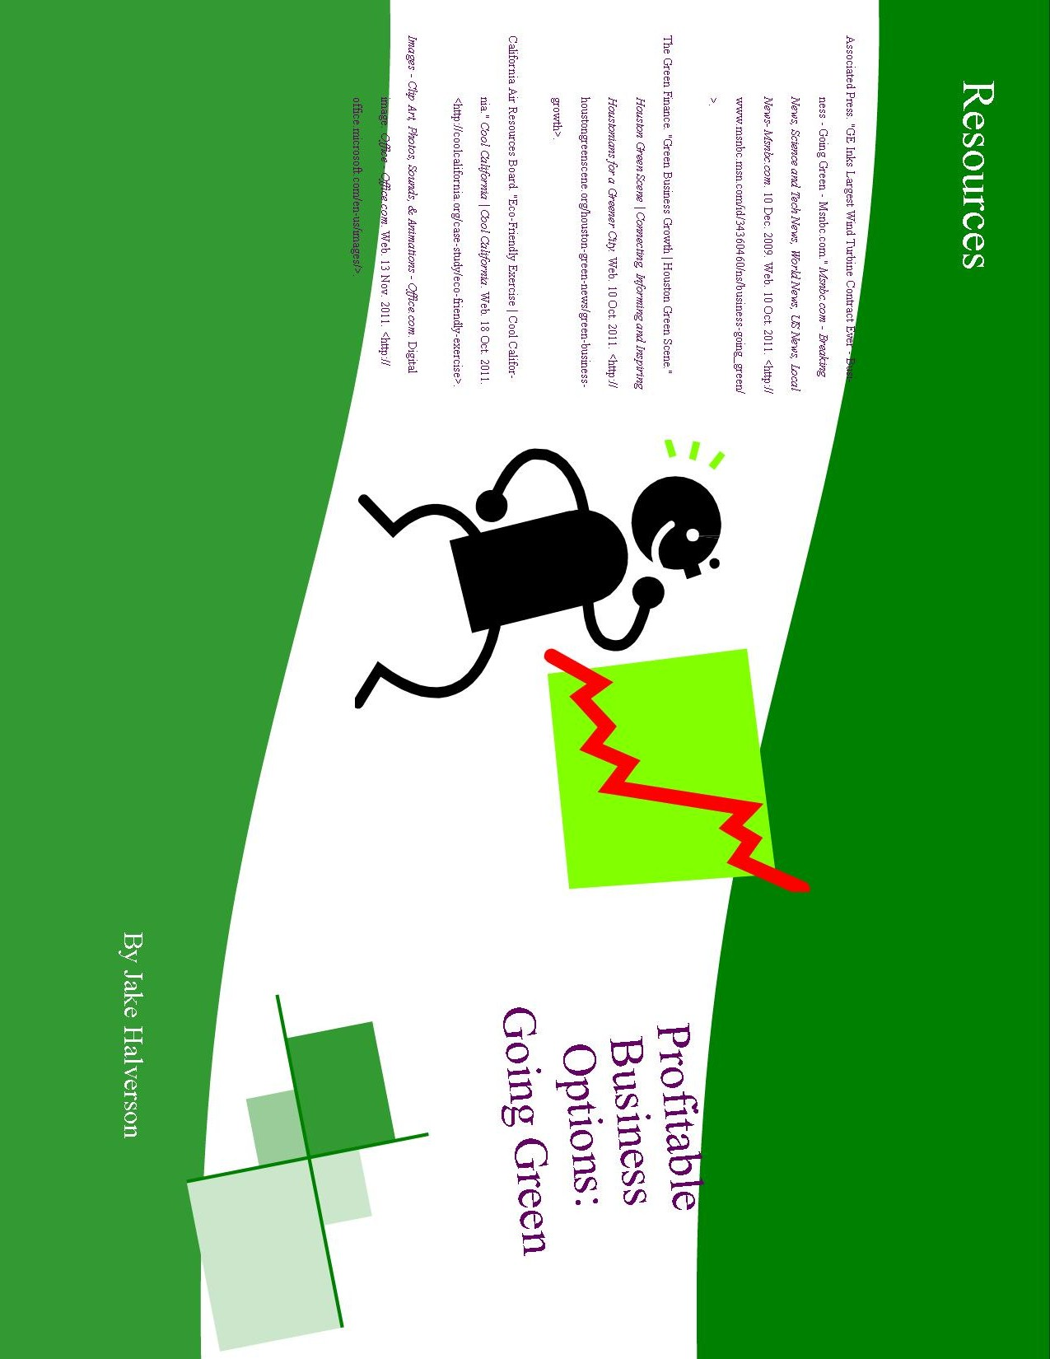
[Brochure: Outside]

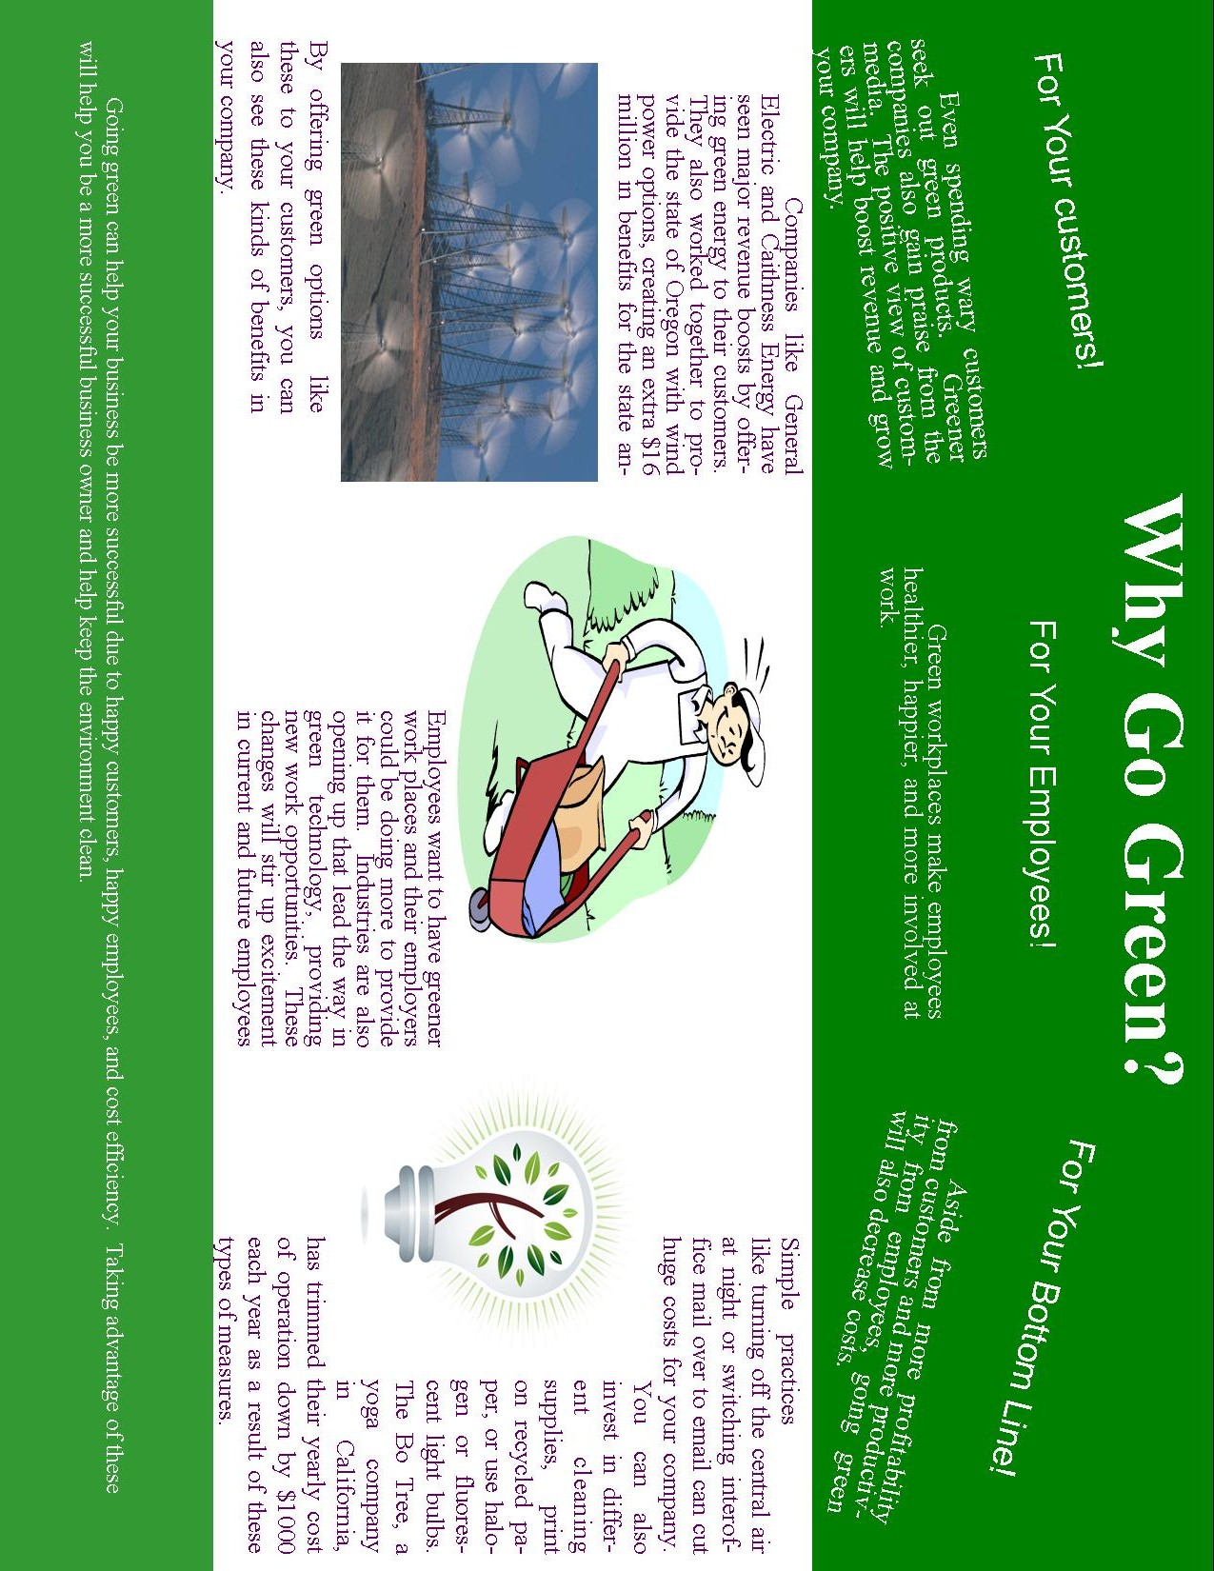
[Brochure: Inside]

